USER INTERFACE

The two main components of the interface are the musical score (1) and the oscillogram (2). If required, the panels discussed in the following chapter can be added.

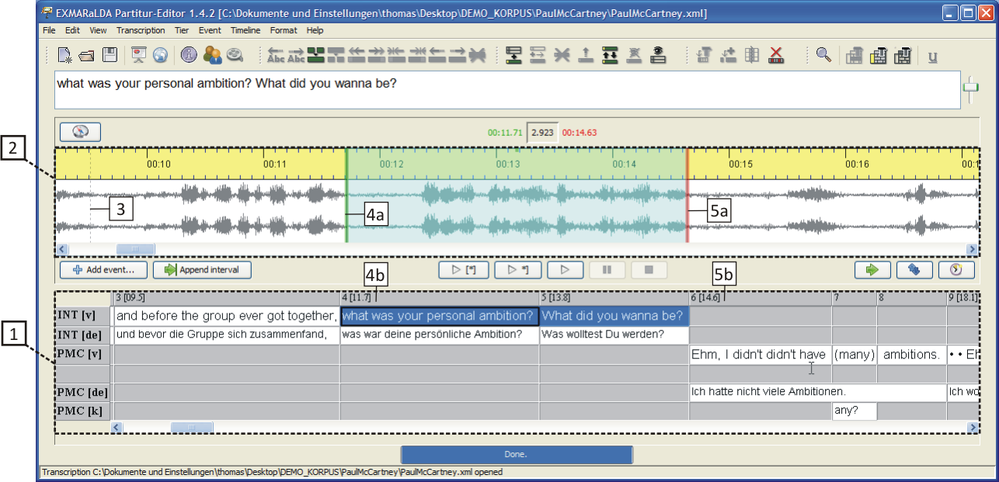

The oscillogram will only be displayed, if the transcription is linked to an audio or video file (via "Transcription > Recordings..."). Should the list of linked recordings not hold a WAV file, only a time line will be displayed instead of the oscillogram:

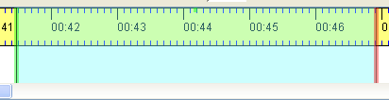

The buttons for playing the recording can be found between the oscillogram and the musical score:

Their functions are (from right to left):
(1) Play the second before the selection in the oscillogram
(2) Play the first second of the selection
(3) Play the current selection (Shortcut: Ctrl + Space)
(4) Play the last second of the selection (Shortcut: Ctrl + Shift + Space)
(5) Play the first second after the selection
(6) Loop the selection
(7) Play from cursor position (Shortcut: Ctrl + F4)
(8) Pause (Shortcut: Ctrl + F5)
(9) Stop (Shortcut: Ctrl + F6)

The musical score and the oscillogram are linked to each other. Thus, if the current selection of the musical score is equipped with absolute time values, the start (4b) and end point (5b) of the musical score will coincide with the start (4a) and end point (5a) of the oscillogram selection. In reverse, the buttons "Add event..." and "Append interval" can be used to insert events or time intervals into the musical score according to the current selection in the oscillogram. A detailed description can be found in the document How to make a transcription from a digital recording.

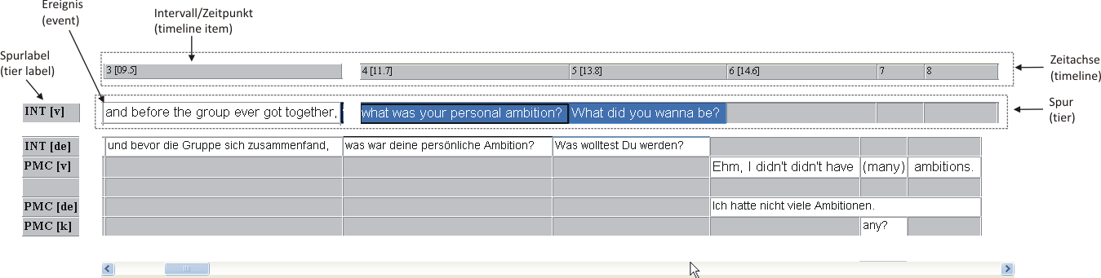

The musical score is composed of one or more tiers. Every tier contains events that are assigned to one or more intervals on the timeline. A detailed description of the basic units of an EXMARaLDA transcription can be found in the document Understanding the basics of EXMARaLDA.

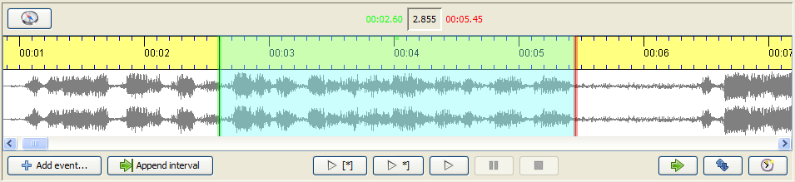

The visual nature of the oscillogram view can be altered by scrolling:

- Pressing and holding the Control-key and scrolling up or down zooms in and out of the display horizontally, hence, a greater or smaller time unit is then shown per pixel.
- Pressing and holding the Control and the Shift key and scrolling up or down zooms in and out of the display vertically, hence, the oscillations are increased and decreased in size. This can be particularly useful, if the overall recording volume is too soft.

If the current selection in the oscillogram is connected to the musical score, the selection boundaries will be displayed in green (at the beginning) and in red (at the end). If the selection boundaries in the oscillogram are altered in this state, these alterations will also be applied to the connected time values in the musical score. If the oscillogram view and the musical score are not connected, the selection boundaries will be displayed in blue.

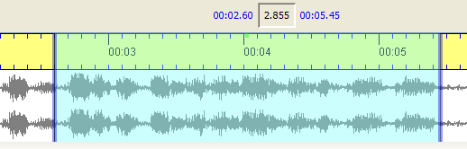

The buttons to modify the oscillogram can be found under it on the right hand side:

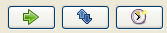

The first button("Shift selection") moves the current selection in such a way that the new starting point is the same as the previous endpoint. The length of the selection is maintained:

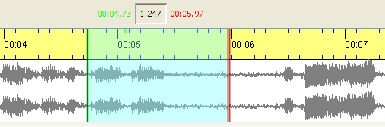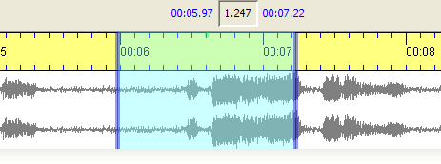

The second button ("Detach selection") keeps the current selection, but detaches the musical score from it. The colours of the boundaries then change from green/red to blue. The third button ("Assign times") assigns the start and end time of the current selection in the oscillogram to the currently selected time points in the musical score.

The selection boundaries in the oscillogram can be changed in the following way:
- Clicking and pulling with the mouse
- Placing the cursor near one of the boundaries and scrolling thereafter moves the boundary to the right or left.
- "Alt + Right Arrow key" moves the right boundary of the selection to the right. "Alt +Left arrow key" moves the right boundary to the left. Pressing Shift along with Alt and the arrow keys moves the left boundary of the selection.
- Placing the cursor in the middle of the selection and scrolling thereafter moves the entire boundary to the right or left.

There are two possible ways to choose longer selections:

- Using the button "Navigate in the recording" (above the oscillogram view to the left) opens a dialog that allows input of selection boundaries in numbers:

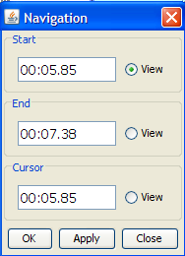

- Double-clicking sets a mark in the oscillogram view. The next double-click then places a selection from the marked position up to the second double-click.

